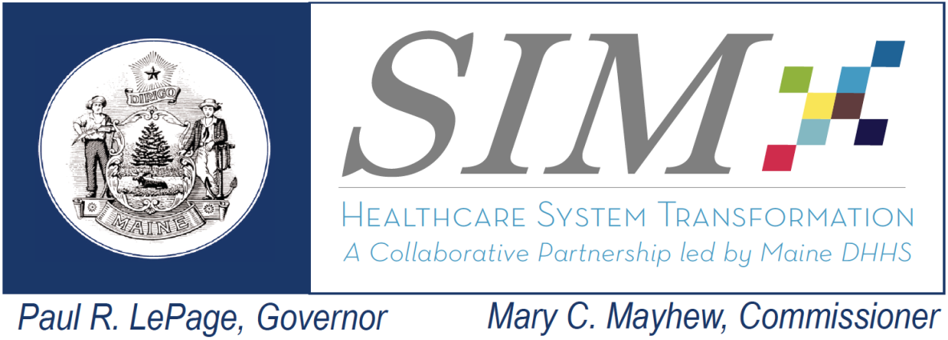 | SIM Steering Committee  Friday, January 15, 2016  10:30am-11:30am  Camden National Ice Vault  Conference Room 1

Attendance:
Jay Yoe, PhD, DHHS – Continuous Quality Improvement
Deb Wigand, DHHS – Maine CDC
Rhonda Selvin, APRN (via phone)
Sara Sylvester, Administrator, Genesis Healthcare Oak Grove Center (via phone)
Kristine Ossenfort, Anthem (via phone)
Katie Fullam Harris, VP, Gov. and Emp. Relations, MaineHealth (via phone)
Dale Hamilton, Executive Director, Community Health and Counseling Services (via phone)
Lisa Letourneau, MD, Maine Quality Counts (via phone)
Randy Chenard, SIM Program Director
Stefanie Nadeau, Director, OMS/DHHS
Shaun Alfreds, COO, HIN- (via phone)
Andrew Webber, CEO, MHMC
Noah Nesin, MD (via phone)
Jack Comart, Maine Equal Justice Partners
Fran Jensen, CMMI (via phone)

Interested Parties:
Lisa Tuttle, Maine Quality Counts (via phone)
Amy Dix, Director of VBP, OMS)
Lisa Nolan, MHMC (via phone)
Jade Marple, Lewin (via phone)
Lyndsay Sanborn, MHMC
Kathy Woods, Lewin (via phone)
David Winslow, MHA
Sheryl Peavey, DHHS
Jade Christie Maples, Lewin
Helena Petersen, MQC
Frank Johnson, MHMC
Kathryn Pelletreau, MAHP

Absence:
Lynn Duby, CEO, Crisis and Counseling Centers (retired)
Eric Cioppa, Superintendent, Bureau of Insurance
Rose Strout, MaineCare Member
Mary Pryblo, St. Joseph’s Hospital
Penny Townsend, Wellness Manager, Cianbro

All meeting documents available at: http://www.maine.gov/dhhs/oms/sim/steering/index.shtml
Agenda | Discussion/Decisions | Next Steps
1-Welcome – Minutes Review and Acceptance | Approve Steering Committee minutes from December Steering Committee meeting  There were two changes to the recorded attendance at the December 4 Steering Committee meeting. Minutes were approved with updates to the attendance list.
2- SIM Objective Review | Objective: Review Maine Leadership Team decisions regarding the Strategic Objective Review Team and discuss key next steps for SIM program  Randy gave an overview of the purpose of this meeting and the activities that led up to the decisions by the MLT. He went over the memo from the MLT to the Steering Committee, and explained that the MLT was also receiving presentation on the SIM objectives by the partners in the same general timeframe as the SORT, and the information from their perspective on longer term healthcare transformation sustainability is also included in the memo. He went through the different documents provided to the Steering Committee today, and there is a decision document, that includes the SORT, Steering, and MLT recommendations and decisions for each objective reviewed through this process.  Randy went over the MLT decisions PowerPoint presentation, which detailed the components that impacted the MLT’s thought process. He said that the MLT was very much focused on the impact of the objectives to SIM goals  Fran expressed her appreciation for the hard work and the SORT process that was developed as a key component of innovation is adjusting direction based on experience, and thereforeone of the goals of the SIM program; ielooking at what can be changed to achieve the ultimate SIM goals. She said that one of the hopes for SIM is to cultivate innovation in state government which is challenge in any large organization. Through the use of data and looking at early evaluation results, Maine is using that information to drive improvement and decisions fairly rapidly. Have shared this process with CMMI team and with other states, and she plans to elevate this process further to show the great work that was done.  Randy said that when SIM started they were looking to advance very broadly across six strategic fronts, and do so concurrently; but now, based on the experience gained thus far, they are increasing focus and narrowing it to things where SIM is getting some traction and concentrate efforts in those areas. Randy pulled up SIM strategic framework, to show what activities were occurring in years One and Two. He then demonstrated a new strategic framework, which visually demonstrates the changes to the activities to be performed in Year Three. He said that there are some objectives that no longer appear for Year Three, and some that have a significantly narrower focus in order to move the needle on specific outcomes in a very real way. Randy explained next steps; the MLT will be providing the areas of focus in the very near term for year three. The SIM Program Team will be looking to develop a workgroup made up of Steering Committee members to provide recommendations on most effective ways to achieve specific SIM goals, recommendations will go back to MLT to make decisions, then SIM Program will work on implementation of the recommendations. Looking to advance fairly quickly. He thanked everyone for taking time to attend meetings that have sporadically popped up. He said they are hoping to create the workgroup in early February, have recommendations by late February, which will be brought to the MLT in early March for decisions, and then the SIM program team will be working on implementation.  Randy said it was extremely important to note that the adjustments that are being made are in no way a reflection that the work to date performed under SIM was not valuable to broader healthcare transformation. These adjustments are a result of a sharpened focus during a test period that is short term. There are a lot of pieces of work done under SIM that are extremely valuable to moving healthcare in Maine to a better place.  Stefanie said that the objectives, and the grant as a whole, are tests, and where there were changes in direction is not indication of quality of work, but just focusing on what can move SIM forward.  Sheryl Peavey stated that SIM is only a piece of a larger transformation effort and SIM is time limited , but she certainly would encourage many of the activities to continue because of value to the broader system.  Randy went through the Decision Grid, which included each SIM objective and details the initial recommendation from SORT, Steering Committee comments, and then the MLT decision.  MECDC:  1st objective- MLT agreed with SORT/SC recommendation  2nd objective- MLT agreed with SORT/SC recommendation, part of their recommendation was to focus on those that have become more successful, more discussion will happen in the Steering Committee soon.  HIN:  1st objective- MLT agreed with SORT/Steering Committee recommendations  2nd objective- MLT agreed with SORT/Steering Committee recommendations  3rd objective- MLT agreed with SORT/Steering Committee recommendations, Steering Committee had requested more information about barriers these BH are experiencing in sharing bidirectionally.  4th objective- MLT agreed with SORT/Steering Committee recommendations  5th objective- pilot has concluded so there is no more funding allocated toward it, wanted to receive information on evaluation of pilot, would like to see results  MQC  1st Objective- MLT agreed with SORT/SC recommendation that the Learning Collaborative continue with greater level of focus on outcome areas. MLT will provide what the focus areas are and the agendas will be approved through the Steering Committee.  Dr. Letourneau said that once they begin planning the June Learning Session they are happy to check in with the Steering Committee on the agenda. She also started that MaineCare staff was already participating in planning meetings.  2nd Objective- MLT agreed with SORT/Steering Committee recommendations, same as 1st objective with approval of agendas and activities.  3rd Objective- was concluded and no more funding allocated.  MHMC  Objective 1, Hypothesis A- MLT agreed with SORT and Steering Committee recommendations; wanted more information around data vetting process.  Objective 1, Hypothesis B- MLT agreed with SORT and Steering Committee recommendations; the CEO Summits should no longer continue, not direct enough cause and effect on specific focus areas. Not to be continued under SIM. Databook didn’t need to be updated until after SIM.  Lisa Nolan explained that slimmer supplement was put on the website, not as much changing around the data so there was not the full blown hard copy.  Objective 1, Hypothesis C- MLT differed from SORT and Steering Committee recommendations; MLT agreed activities are valuable, but that they don’t align with sharpening focus of SIM and these activities will no longer be funded through SIM.  Objective 2, Hypothesis D- MLT agreed with SORT and Steering Committee recommendation of continuing with very sharpened focus. More to come on that.  Objective 2, Hypothesis E- MLT said that the only work that should be continued under this group is to convene periodically to review the measure set and update as necessary.  Objective 2, Hypothesis F- MLT agreed with SORT and Steering Committee recommendation, and decided to end funding.  Objective 3, Hypothesis G- MLT agreed with SORT and Steering Committee recommendations, and is looking for a sharpened focus.  Objective 3, Hypothesis H- MLT agreed to SORT and Steering Committee recommendations  Objective 4- MLT agreed with SORT/Steering Committee recommendations; there needs to be an update to the work plan under this objective to pull out where MHMC is supporting ACs under this objective, and those activities are the only ones that will continue to be funded to make sure there is no hiccup to analytics support.  Objective 5, Hypothesis J- MLT agreed with SORT/Steering Committee recommendation on practice reports, wanted a sharpened focus and perhaps technical assistance (who how where will be decided later)  Objective 6- MLT agreed with SORT/Steering Committee recommendations to no longer continue this, understands value of that type of work.  Concludes review of decisions MLT made.  Andy Webber said that these decisions obviously impact the work of the Coalition going forward. He appreciated the comment of how the decisions are not reflective of quality of work, but rather the desire to focus on short term impacts. Coalition staff are disappointed the the convening activities do not have same degree of support for their contribution to the short term impacts. He stated that convening is a part of the DNA and mission of their organization . It is something that they will do after SIM, and they DO feel it is having an impact, although those impacts might not be able to be measured by Jay in a year. The Coalition will figure out how that convening function in those critical areas will continue, and just because SIM will no longer fund some of these activities, the Coalition believes they are critical to the overall healthcare transformation in Maine. He said he hopes there will be some consideration by state through engagement and support and even as it becomes the Coalition’s responsibility to run. He said they disagree with some of the recommendations coming out of the SORT and have some concerns of process and timing of the review, but they believe that work needs to continue and they will figure out how to make it continue.  Randy thanked Andy for his comments.  It was asked what the process will be for pulling together the work group.  Randy said they will be looking for volunteers and will look to leadership to determine what representation is necessary. Steering Committee members will be hearing more from SIM program in the near future. | SIM Program Team will be reaching out to the Steering Committee within the next few weeks for volunteers to participate in the Recommendations work group, under guidance from the MLT.
11- Public Comment | No public comment.

.

